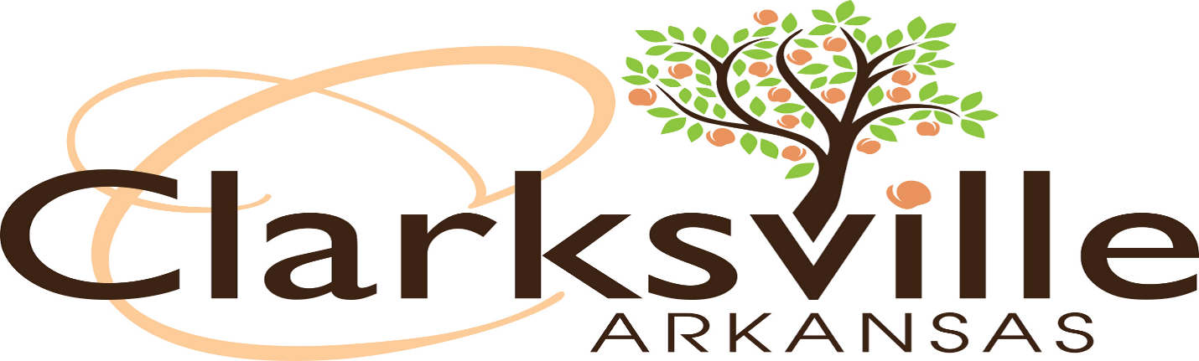

APPLICATION FOR PRIVATE CLUB PERMIT
MUST BE A NON-PROFIT CORPORATION
On file at the Arkansas Secretary of State’s Office
INSTRUCTIONS
1. Answer all questions correctly and in full. PLEASE PRINT IN INK OR TYPE.
2. Application fee is $1,500.00 and must be submitted with this application.
3. A copy of the application to the State Alcohol Beverage Control Division must be attached.
3. Applicant must be a citizen of the United States or a permanent resident alien (must provide a copy of green card) and a resident of Arkansas.
4. The following additional materials must be submitted with your application:
a. A current list of names and addresses of all board members.
b. The address where the business will be located. If the non-profit corporation does not own the property, a copy of the lease must be attached.
5. If the non-profit does not begin operation within six months of the permit being issued, the permit will be null and void.
6. If the non-profit does not operate the business for a continual six months, the permit will be null and void.
7. Permit renewals are $250.00 and due between December 1st and December 31st of each year.
MAIL OR DELIVER TO:
Clarksville City Clerk/Treasurer
205 Walnut Street
Clarksville, AR 72830

